**LAB # 3**

1. **Write a program which takes an integer value (k) as input and prints the sequence of numbers from k to 0 in descending order.**

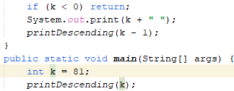**Code: Output**



1. **Write a program to reverse your full name using Recursion.**

**Code: Output:**

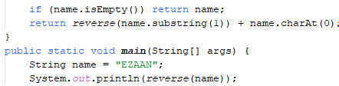

1. **Write a program to calculate the sum of numbers from 1 to N using recursion. N should be user input.**

**Code:**

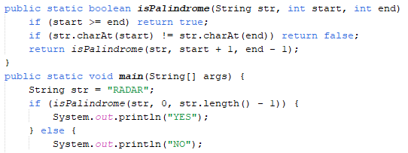

**Output:**



1. **Write a recursive program to calculate the sum of elements in an array.**

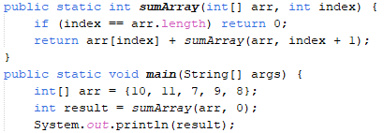**Code: Output:**



**5. Write a recursive program to calculate the factorial of a given integer n**

**Code: Output:**

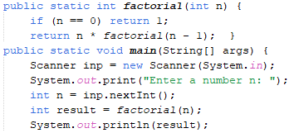



1. **Write a program to count the digits of a given number using recursion.**

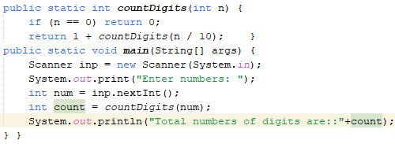**Code:**

**Output:**

